Q1) Return Address of the function samp_func is 0x00010538.
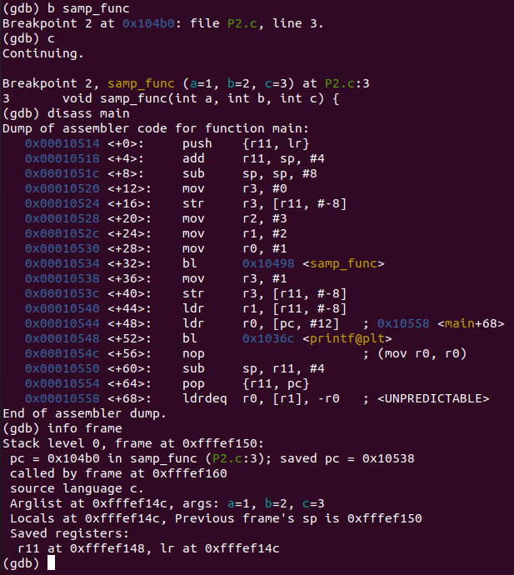
Q2) Return address of samp_func is stored at the address 0xfffef14c on the stack (lr address).
Inspecting the memory at the address 0xfffef14c for verification:
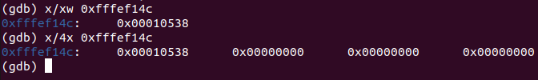
It has 0x00010538, which is the return address of samp_func.

Q3) buffer1 is stored on the stack at the address 0xfffef138

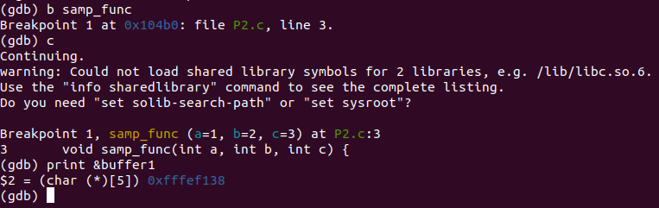

Q4) 20 bytes

Address of buffer1: print &buffer1 : 0xfffef130
Return Address of samp_func: &lr : 0xfffef14c
Distance = Address of Return Address – Address of Buffer1

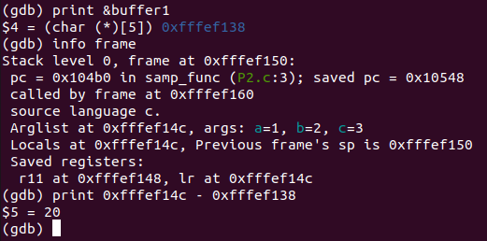
0xfffef14c – 0xfffef138=20 bytes

Q5) P = 20, the difference calculated in the previous question (offset).
Q = 16

Previously when P = 0, Q = 0:

Now as we update P = 20, keeping Q as 0,
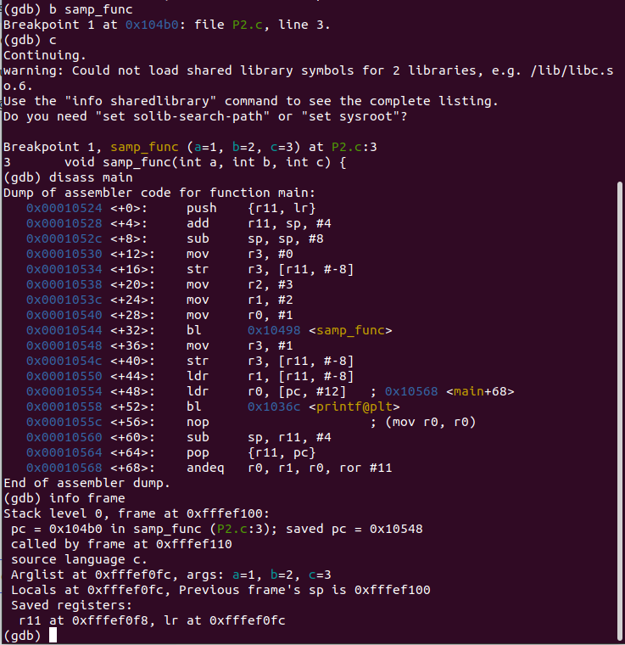
Return Address of the function samp_func now is 0x00010548.

Hence, 0x00010548 - 0x00010538 = 0x10
Which is 16 in decimal.

P = 20
Q = 16
This will make line 12 to be skipped from execution.

